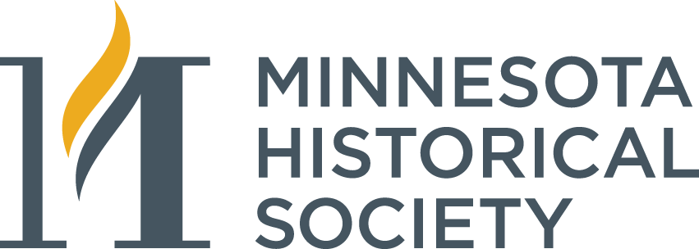

Declaration of Intent

I believe in the mission of the Minnesota Historical Society. I take great pleasure in declaring my intention to help provide for MNHS’s future needs with a gift to the endowment through:

- my will
- a life insurance policy
- a trust agreement
- a cash/pledge gift ____________
- other (please specify) _________

I would like to designate my gift to be:

- unrestricted, for use where most needed
- restricted to a program area of special interest: ___________________

If a planned gift ~ MNHS requests that you provide a copy of the legal document (or portion thereof to MNHS) governing this gift. The approximate value of my gift today is $____________. (MNHS understands that the actual amount received may be more or less than the amount herein stated.)

I understand and agree that the endowment will be managed in conjunction with the Minnesota Historical Society’s other endowment to provide support in perpetuity, and that distributions from the endowment in support of my named fund will be determined annually in accordance with MNHS’s then policy on income distributions. I further understand that any realized earnings in excess of the authorized annual distribution shall be added to the corpus of the Endowment.

- Please list my name in recognition publications as:

_________________________________________________________________

__________________________________________ ____________________
Signature Date

